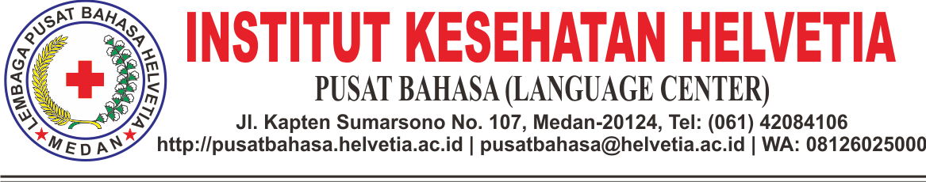

**DAFTAR NAMA PESERTA UJIAN TOEFL GELOMBANG I RABU, 1 AGUSTUS 2018**

**PUKUL 14.00 – 16.00**

**AKPER – AKBID – INSTITUT KESEHATAN HELVETIA**

|  |  |  |  |
| --- | --- | --- | --- |
| NO | NAMA | NIM | PRODI |
| 1. | YULIA ERNIDA | 1404195277 | S2 KESPRO |
| 2. | YASBIN HUTABARAT | 1505195088 | S2 KESMAS |
| 3. | RAHMI FADHILA | 1303195052 | S2 MRS |
| 4. | NURUL AFDILLA | 1505195271 | S2 MKES |
| 5. | ANJELI ACEH | 1415180017 | D-III KEB |
| 6. | RINA SRIWAHYUNI | 1404195066 | S2 KMPK |
| 7. | TEUKU MURSALAT | 1404195081 | S2 KMPK |
| 8. | MUTIA FITRI | 1505195052 | S2 KMPK |
| 9. | SARA DEWIOLA | 1404195074 | S2 KMPK |
| 10. | YULIA DEVI ASTUTI | 1505195198 | S2 MRS |
| 11. | FITRI ANNAL | 1505195175 | S2 PROMKES |
| 12. | ARVAN DWI FEBRIAN | 1404195007 | S2 KMPK |
| 13. | TIKA JAYANTI | 1404195082 | S2 |
| 14. | MALJUM ALMIS | 1505195201 | S2 KESMAS |
| 15. | FRINDOS RIFZAL | 1303195101 | S2 MRS |
| 16. | LUSIA NATALIS PINEM | 1505195213 | S2 MKES |
| 17. | MERIZA SILVIA PUTRI | 1505195156 | S2 KESMAS |
| 18. | IDA BASA NAINGGOLAN | 1404195144 | S2 KESMAS |
| 19. | BENNY C PURBA | 1404195100 | S2 KESMAS |
| 20. | CHRISTIYEN SRIMELVA SARAGIH | 1505195209 | S2 KESMAS |
| 21. | KHAIRUNNISA | 1505195311 | S2 IKM |
| 22. | JOYCE | 1505195012 | S2 ARS |
| 23. | WAHYU AZWA | 1414192055 | S1 IKM |
| 24. | MHD NURHIDAYAT | 1404195046 | S2 MRS |
| 25. | MARESYA ANGELIN | 1404195040 | S2 MRS |
| 26. | IRAWATY | 1404195244 | S2 MRS |
| 27. | GISNA HARTINI | 1505195197 | S2 MRS |
| 28. | TRILIA MANDASARI | 1505195059 | S2 MRS |
| 29. | ELVIRA ROSA HRP | 1505195273 | S2 MKM |
| 30. | YUSWITA | 1505195260 | S2 MKM |
| 31. | MEUTIA PARADHIBA | 1505195323 | S2 MKM |
| 32. | VERA FRANSISKA | 1505195267 | S2 MKM |
| 33. | IDAMAWATI | 1505195152 | S2 MKM |
| 34. | RINALDO WINATA | 1505195270 | S2 IKM |
| 35. | RISMA SONDANG KRISTINA | 1505195280 | S2 MRS |
| 36. | FEBRIANA SALAWAZO | 1516180088 | D3 KEB |
| 37. | IDAMAN SYUKUR MAWATI LAIA | 1516180123 | D2 KEB |
| 38. | NURJANNAH BANIYATI | 1505195203 | S2 PROMKES |
| 39. | SAFWALIZA | 1303195021 | S2 ARS |
| 40. | ALVIN KURNIA ARIF LUBIS | 1414192002 | S1 IKM |
| 41. | ELVIRA ROS LAIA | 1516180060 | D3 KEB |
| 42. | KLAA FIMARIA LAIA | 1516180147 | D3 KEB |
| 43. | ARMA AFIFI SIAGIAN | 1414192005 | IKM REG |
| 44. | ELY LASRIANY | 1414192014 | IKM REG |
| 45. | ICHA ARDITA SARI | 1414192020 | IKM REG |
| 46. | NINA ARDIYANTI SIREGAR | 1414192031 | IKM REG |
| 47. | NADIA ABDULLAH | 1414192030 | IKM REG |
| 48. | ENDRIATI SAMIMAHA | 1516180066 | D3 KEB |
| 49. | DEFLIANA HAREFA | 1516180029 | D3 KEB |
| 50. | EFRITAWATI TAFONAO | 1516180055 | D3 KEB |

***CATATAN:***

1. ***PESERTA TOEFL HADIR PADA PUKUL 14.00 WIB.***
2. ***PESERTA TOEFL DIWAJIBKAN MEMBAWA KTM/KTP***
3. ***PESERTA TOEFL TIDAK DIPERKENANKAN MEMBAWA ALAT KOMUNIKASI BERUPA HANDPHONE DAN ALAT TULIS.***
4. ***PESERTA TOEFL TIDAK DIPERKENANKAN UNTUK BEKERJASAMA DALAM MENGERJAKAN SOAL UJIAN.***
5. ***WAKTU PELAKSANAAN UJIAN TOEFL 120 MENIT.***
6. ***UJIAN TOEFL DILAKSANAKAN DI LAB. BAHASA LANTAI 2.***

Medan, 2017

Tim Pusat Bahasa